**Assignment-2**

**Source Code:**

#Donut Chart

import pandas as pd import matplotlib.pyplot as plt

data = pd.read_csv("C:\\Users\\yogap\\Downloads\\supermarket_sales - Sheet1.csv") df = pd.DataFrame(data)

# Grouping data by branch and gender and summing up gross income

grouped_data = df.groupby(['Branch', 'Gender'])['gross income'].sum().reset_index()

# Plotting the donut chart plt.figure(figsize=(8, 6))

colors = ['#ff9999','#66b3ff','#99ff99','#ffcc99'] total_income = grouped_data['gross income'].sum()

plt.pie(grouped_data['gross income'], labels=grouped_data.apply(lambda x: f"{x['Branch']} - {x['Gender']}", axis=1), autopct=lambda p: '{:.0f}'.format(p * total_income / 100), startangle=90, colors=colors) plt.title('Gross Income Distribution by Branch and Gender') plt.gca().add_artist(plt.Circle((0,0),0.70,fc='white')) plt.axis('equal') plt.show()

**OUTPUT:**

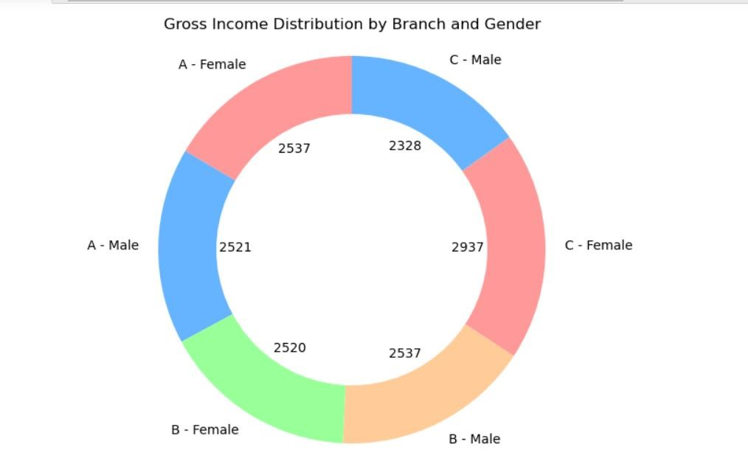

**Source Code:**

**#Area Chart**

import pandas as pd import matplotlib.pyplot as plt

data = pd.read_csv("C:\\Users\\yogap\\Downloads\\supermarket_sales - Sheet1.csv") df = pd.DataFrame(data)

# Grouping data by branch and product line and summing up gross income

grouped_data = df.groupby(['Payment', 'Product line'])['gross income'].sum().reset_index()

# Pivot the data for visualization

pivot_data = grouped_data.pivot(index='Payment', columns='Product line', values='gross income').fillna(0)

# Plotting the area chart plt.figure(figsize=(10, 6)) pivot_data.plot.area(stacked=True, cmap='tab10') plt.title('Historical Sales Data by Payment and Product Line') plt.xlabel('Payment') plt.ylabel('Product Line') plt.xticks(rotation=0)

plt.legend(title='Product line', bbox_to_anchor=(1.05, 1), loc='upper left') plt.tight_layout() plt.show()

**OUTPUT:**

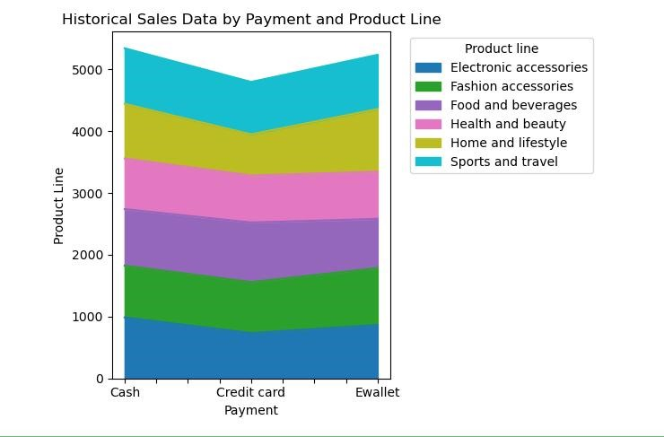

**Source Code:**

#Text Table

import pandas as pd import matplotlib.pyplot as plt

data = pd.read_csv("C:\\Users\\yogap\\Downloads\\supermarket_sales - Sheet2.csv") df = pd.DataFrame(data)

# Convert DataFrame to tabular format with pipe format table = tabulate(df, headers='keys', tablefmt='plain', showindex=False)

# Print the table print(table)

**OUTPUT:**

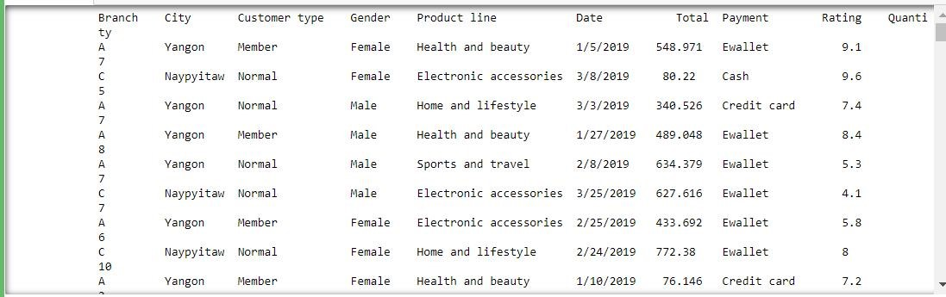

**Source Code:**

#Highlighted table

import pandas as pd # Sample data

data = pd.read_csv("C:\\Users\\yogap\\Downloads\\supermarket_sales - Sheet2.csv")

# Convert data to DataFrame df = pd.DataFrame(data)

# Define function to highlight maximum value in each column def highlight_max(s): is_max = s == s.max()

return ['background-color: yellow' if v else '' for v in is_max]

# Apply highlight function to the DataFrame highlighted_df = df.style.apply(highlight_max) # Display the highlighted table highlighted_df

**OUTPUT:**

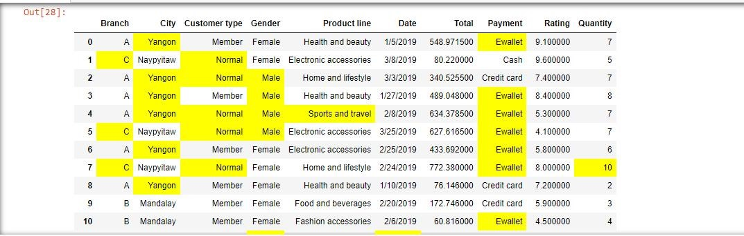

**Source Code:** #WordCloud

from wordcloud import WordCloud import matplotlib.pyplot as plt

# Description

description = "The growth of supermarkets in most populated cities is increasing and market competitions are also high."

# Sample data with updated 'City' data data = {

'Branch': ['Branch A', 'Branch B', 'Branch C'],

'Gender': ['Male', 'Female', 'Male'],

'City': ['Yangon', 'Mandalay', 'Naypyitaw'], # Updated 'City' data

'Product line': ['Health and beauty', 'Sports and travel', 'Home and lifestyle']

}

# Combine text from description and columns into a single string

text = description + ' ' + ' '.join(' '.join(str(value) for value in row) for row in zip(*data.values()))

# Generate word cloud

wordcloud = WordCloud(width=800, height=400, background_color='white').generate(text)

# Plot word cloud

plt.figure(figsize=(10, 6))

plt.imshow(wordcloud, interpolation='bilinear') plt.axis('off')

plt.title('Word Cloud of Branch And product Line') plt.show()

**OUTPUT:**



**Source Code:**

#Funnel Chart

import matplotlib.pyplot as plt # Provided sample data

data = pd.read_csv("C:\\Users\\yogap\\Downloads\\supermarket_sales - Sheet1.csv") df = pd.DataFrame(data) # Plotting the funnel chart plt.figure(figsize=(8, 6))

plt.barh(data['Product line'], data['Total'], color='skyblue') plt.xlabel('Total Sales') plt.ylabel('Product line')

plt.title('Funnel Chart of Total Sales by product Line')

plt.gca().invert_yaxis() # Invert y-axis to show the top-down funnel shape plt.show()

**OUTPUT:**

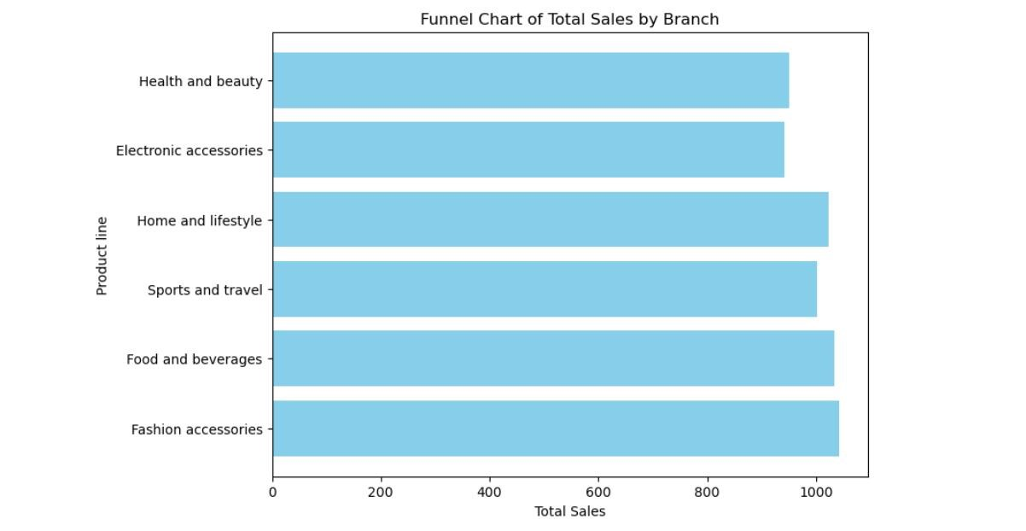

**Source Code :**

#Waterfall Chart

import matplotlib.pyplot as plt

# Sample data data = {

'Product line': ['Health and beauty', 'Sports and travel', 'Home and lifestyle', 'Fashion accessories', 'Electronic accessories', 'Total Costs', 'Net Profit'],

'Amount': [100000, 60000, 30000, 90000, -20000, -50000, 40000]

}

# Calculate cumulative sum data['Cumulative'] = [sum(data['Amount'][:i+1]) for i in range(len(data['Amount']))] # Plot waterfall chart plt.figure(figsize=(10, 6)) plt.bar(data['Product line'], data['Amount'], color='b', alpha=0.5, align='center') plt.plot(data['Product line'], data['Cumulative'], color='orange', marker='o') plt.title('Waterfall Chart of Product Line and Costs') plt.xlabel('Product line') plt.ylabel('Amount') plt.xticks(rotation=45) plt.grid(axis='y', linestyle='--', alpha=0.7) plt.tight_layout() plt.show()

**OUTPUT:**

